Robot Pathfinding Using Search Algorithms

Final Project Report

Course: CSM4880
Student Name: Haris Muhammad Khurshid
Student ID: E12795713
Project Title: Robot Pathfinding Using BFS and A* Search Algorithms

This project aims to develop a robot path planning system that will be able to find a path between two locations in a 2D grid that is free from any obstacles. There are open and blocked cells in the grid, and the robot is capable of moving up, down, left, and right. In essence, the problem is comparable to finding the shortest path in an unweighted graph.
This project demonstrates the distinction between blind and informed search methods.
INTRODUCTION:
Pathfinding is among the most significant challenges in computer science, robotics, artificial intelligence, and gaming. An intelligent agent such as a robot, game entity, or a self-driving vehicle is required to travel from one point to another by avoiding any obstacles. A robot in a warehouse is supposed to travel from the charging dock to the shelves, a delivery robot should be able to move in the sidewalk environment, and a game entity should navigate around the obstacles in the gaming environment.
The primary concept of the proposed work is that of a simulation of a robot in a 2-D grid-based environment. The initial location of the robot and its final destination in the grid must be predetermined, with the robot being unable to traverse through cells containing obstacles. The environment will be depicted using a matrix, where open cells allow for traversal of the robot, whereas blocked cells signify obstacles in the way. As such, the robot can only traverse in four directions: left, right, up, and down. Such limitation simplifies the problem statement greatly, yet allows demonstrating key features of the path finding algorithms.
The selected problem is interesting in the sense that several different approaches are available. Specifically, the use of such an algorithm as Breadth First Search guarantees finding the optimal route, but has no knowledge about the goal location; as such, it explores all potential paths level-by-level. Conversely, the approach known as A* Search uses heuristic in the decision making, resulting in finding of the goal in less explored cells.
While originally the proposal was concerned with designing a system for comparison between blind search and informed search, this has been extended into BFS and A* with multiple heuristics, namely Manhattan, Euclidean, and Chebyshev distances. The addition has been made based on the suggestions from the instructor about comparison between multiple heuristics as well as testing the algorithms on the same grid.
The report submitted adheres to the structure of the official project report. It includes sections such as introduction, solution approach, experiment, implementation issues, conclusion, references, and submitting of the source code. The official guidelines asked for a report consisting of 10 to 20 pages with discussion of such sections as introduction, solution approach, experiments, implementation issues, conclusion, references, and source code.
Background and Related Work:
The pathfinding problem is normally formulated as a graph traversal problem. A graph is composed of vertices and edges. In this project, we could consider the open cells to be vertices, and every valid move from one open cell to another as an edge. Given that the robot can only move vertically and horizontally, the number of neighbors each cell has is at most four.
The pathfinding problem can be formulated as a single source and destination shortest path problem over an unweighted graph. In our case, since all movements have the same cost, the shortest path is the least costly route. This is the reason that BFS is a good candidate for solving this problem. It expands nodes based on their distance from the source node; hence, by the time it expands the goal node, the path discovered will be the shortest path.
BFS doesn’t incorporate any knowledge about the location of the goal cell. It does not have any idea about which move would take it closer to the goal or vice versa. BFS would blindly expand all the moves possible at the current level.
The A* algorithm solves this problem through the use of a heuristic function. A heuristic function estimates how close a particular node is from the final state. In the A* algorithm, the following formula is used:

f(n)=g(n)+h(n)
Here, g(n) denotes the cost incurred from the starting point to the particular node while h(n) denotes the estimated cost from the particular node to the goal. The algorithm then selects the node with the lowest value of f(n).
For a four-sided grid, the best natural heuristic to be used is Manhattan Distance since it fits into the movement policy. This is calculated as follows:
h(n)=∣r−rg​∣+∣c−cg​∣
In this case, r and c denote the row and column of the present position, respectively, while rg and cg denote the row and column of the goal position. As the robot cannot travel diagonally, it has to travel the difference in rows and the difference in columns separately. This means that Manhattan distance never overestimates the shortest distance.
Euclidean distance refers to the distance between two points in a straight line. It is computed using:
$$h\left(n\right)=√\left(r-rg​\right)2+\left(c-cg​\right)2$$
Euclidean distance finds applicability in physical environments because it calculates the direct geometric distance between two points. But in this particular problem scenario, since the robot moves without diagonals, Euclidean distance becomes relatively less appropriate for representing this kind of movement.
Chebyshev distance is calculated as follows:
h(n)=max(|r-r_g|,|c-c_g|)
Chebyshev distance finds applicability where there is movement along the diagonals because such movements will be able to decrease distances of rows and columns simultaneously. But since in this case there is no diagonal movement, Chebyshev distance has been considered only for the purpose of comparison.
Problem Formulation:
Environment: The environment has been modeled as an N x M grid with open or closed spaces. The robot is provided with the starting coordinate point and the goal coordinate point to reach.
Input for the program will include:
- Grid size.
- Obstacle density.
- Random number generator seed to provide a similar grid for all algorithms.
- Starting coordinate point.
- Goal coordinate point.
- The algorithm or heuristic function that needs to be tested.
- Output for the program will include:
- Whether there exists a path between the starting and goal coordinates.
- Coordinates constituting the optimal path from the start to goal coordinates.
- Length of the optimal path.
- Number of expanded nodes.
- Time taken by the search in milliseconds.
- Static display of the grid, obstacles, explored states, starting point, ending point, and the resultant path.
- Constraints for the problem will be as follows:
- Robot can move only vertically or horizontally.
- Robot must remain within the boundaries of the grid.
- Movement through obstacles is disallowed.
- The environment remains constant while searching.
- Start and goal cells are open.
- Equal cost for each action.
The problem can be formulated as a graph G = (V, E), where V denotes the set of open grid cells and E denotes the set of feasible edges formed by making valid four-directional moves. The objective is to find a path P from source cell s to destination cell t such that each pair of adjacent nodes in the path forms a valid edge.
It is important to note that this problem does not qualify as an NP-hard problem for the assumptions considered in the present study. The problem can be classified as a shortest-path problem defined on an unweighted graph, which can be solved using BFS in polynomial time. This is how the problem was presented in the update report.
Project Goals and Contributions:
The main objective of this project is the comparative performance analysis of several search algorithms applied to a uniform grid-based pathfinding problem. While the actual solution may seem insignificant, this is not the focus of this particular project. Instead, what matters is how many operations were performed by each algorithm before providing the solution.
The contributions of this project include:
- The implementation of the BFS for pathfinding in a 4-direction grid.
- The implementation of the A* algorithm with three different heuristic functions.
- The execution of all algorithms on identical random grids with the same seed.
- Comparison based on number of nodes expanded, runtime, and length of the path.
- Testing different levels of obstacle density to evaluate performance under difficult conditions.
- Use of static rendering of the algorithm steps instead of dynamic drawing.
- A heatmap-like visualization of explored grid nodes.
This project changed from the original proposal in a few important ways. The proposal mainly focused on BFS and A* with basic evaluation metrics. The final version expanded A* by adding multiple heuristics. The instructor specifically recommended trying Euclidean and Chebyshev heuristics for comparison, and the final code includes those options. The final version also improved the visualization design by saving static images after the search completes, instead of showing the search step by step. This makes the program faster and the output easier to understand.
Solution Approach:
The approach uses a Java modular code. The code consists of a number of classes, including:
- Main.java - manages the experiment;
- BFS.java - manages BFS search;
- AStar.java - manages A* search;
- PathResult.java - contains the search result;
- GridImage.java - builds an image to visualize the grid.

The last code has been implemented using Java. In contrast, the mid-project update used Python, since it was being considered for use. The last Java-based approach uses built-in Java collections including Queue, LinkedList, PriorityQueue, arrays, and Random.
Main.java performs generation of the grid, executing all algorithms, measuring the run time, printing results, and generating images. For the grid generation, a boolean matrix is used. The value "true" stands for obstacles, while "false" is used for open cells. A random seed is used in order to fix the generated grid. BFS and all versions of A* will work with the same grid generated with the given seed.
Final test obstacle densities will have values of 10%, 30%, and 40%. It was recommended by the teacher to add obstacle densities above 30% like 10% and 50%. Obstacle densities of 10% and 40% were used besides 30% in final code. It is possible to use 50% by modifying the array in Main.java file.
Breadth-First Search:
Breadth-first search is an uninformed algorithm. There is no heuristic function. Breadth-first search explores nodes at depth d before moving on to nodes at depth d + 1.
For our project, breadth-first search will utilize a queue. The starting node will be pushed into the queue. Then, the process repeats of dequeuing the front node of the queue, testing if it is the goal, and pushing any valid neighboring nodes onto the back of the queue.
The breadth-first search algorithm will use:

An array to keep track of whether a node has been visited.
An array to keep track of the parent for each node.
An array to help with visualization.
A queue to hold the frontier.

Since the grid is unweighted, every move has the same cost, which means breadth-first search will find the optimal solution. This makes breadth-first search a great algorithm to test other algorithms against. One downside of breadth-first search is that it visits unnecessary nodes.
BFS time complexity = O(V + E)
In case of the grid, V would be the number of open spaces while E would be the number of allowed moves from one space to another. Since each node is connected to maximum four other nodes, hence:
Time Complexity = O(N x M)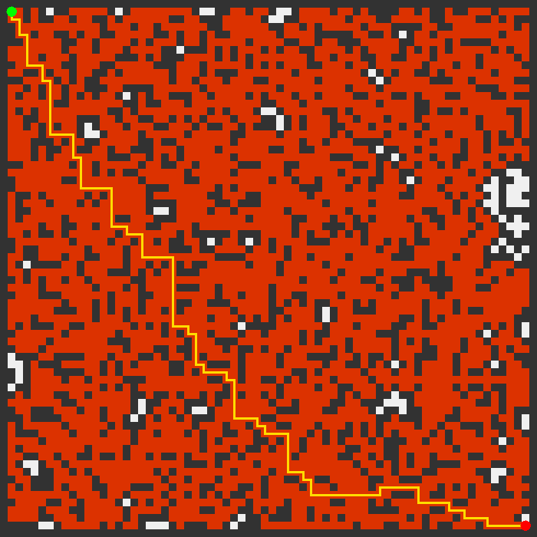
Space Complexity = O(N x M)
A* Search:
A* Search is an informed search algorithm, which takes into account not only the real costs from the starting point but also the estimated costs from each point to the destination point. The expansion process for A* starts with choosing the node having the lowest estimated cost.
The mathematical formulation of A* is:
f(n)=g(n)+h(n)
Whereas:
g(n) represents the cost from the start to node n.
h(n) represents the heuristic estimate from node n to the goal.
f(n) represents the total estimated cost for the path passing through the node n.
In the final implementation, three heuristics can be used:
- Manhattan distance.
- Euclidean distance.
- Chebyshev distance.
The main difference between A* and the usual expansion process lies in the usage of a priority queue instead of the simple queue used by default in other algorithms. Thus, priority queue will take the cell with the minimum value of f(n). In case of several cells with the equal value of f(n), priority queue compares their gScore value.
However, the time complexity of the A* algorithm depends on the accuracy of the heuristic function and the operations performed on the priority queue. The worst-case complexity of A* is:
O(E logV)
The space complexity of A* is:
O(N × M)
where N is the number of nodes in the graph and M is the number of edges.
Heuristics Used in A*:
- 8.1 Manhattan Distance:
Manhattan distance is the most important heuristic in this project. It is calculated as:
$$h(n)=∣r-r_{g}∣+∣c-c_{g}∣$$
This heuristics works in line with the movement in four directions since the robot can only move in vertical and horizontal direction but not in diagonal direction. As such, the Manhattan distance will never underestimate the real path cost in an empty four-directional map and is thus admissible.
For the experiment, Manhattan distance with A* usually expands fewer nodes compared to BFS yet still achieves the same optimal path. This is because Manhattan distance provides A* a hint towards the goal state.
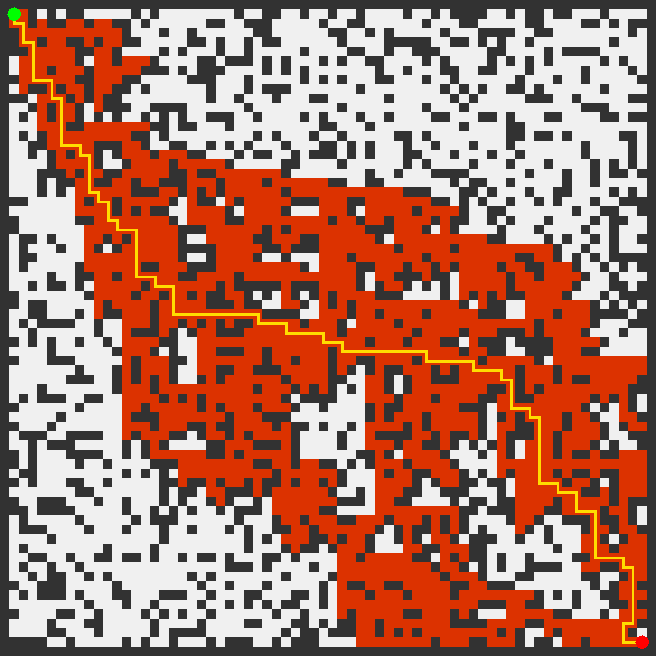

- Euclidean Distance:
Euclidean distance is calculated as:
$$h(n)=\sqrt{{\left(r-r_{g})^{2}+(c-c_{g}\right)}^{2}}$$The heuristic finds out the Euclidean distance between two lo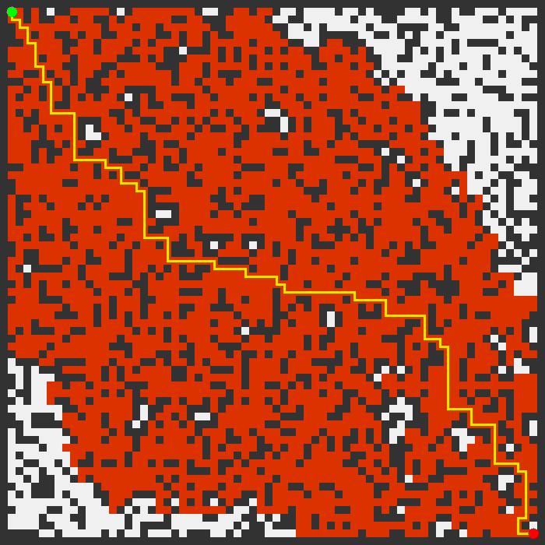cations. This is mostly used in physical maps or for geometrical path finding. But in this case, since diagonal movement cannot take place, Euclidean distance will be less relevant compared to Manhattan distance.
The use of Euclidean distance provides good hints towards the destination location. But it might not be as aggressive as Manhattan distance on a four-directional grid. In the experimental results, A* algorithm with Euclidean distance expanded more nodes than A* with Manhattan distance.

- Chebyshev Distance:
Chebyshev distance is calculated as:
$$h(n)=max⁡(∣r-r_{g}∣,∣c-c_{g}∣)$$
This heuristics works well for a grid that allows diagonal movement. Because this project does not allow diagonal movement, it was used only for the purpose of comparison. It generally provides a lesser estimate compared to the Manhattan distance, thus making the A* algorithm act like BFS.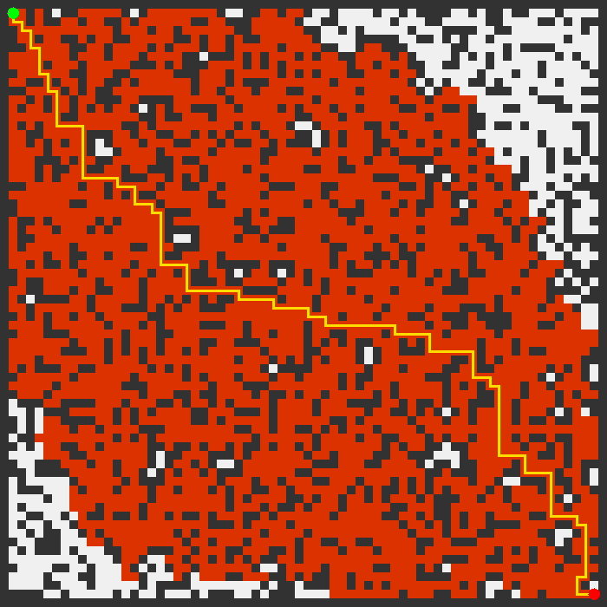

Implementation Details:
The final implementation uses Java and contains five main source files.
- Main.java:
The Main class manages the experiments. It outputs the title of the assignment and the student’s information, initializes the obstacles’ densities, defines the grid size, sets the random seed, creates the grid, executes the BFS and A* algorithms, calculates the running time, and displays the results.
The program utilizes a constant random seed as follows:
long seed = 2342;
It is critical for the proper execution of the program since all algorithms need to work on the same grid. Otherwise, comparing them will be meaningless; one algorithm can show its superiority just because it works on an easier grid.
The obstacles’ densities that will be tested are:
double[] densities = {0.10, 0.30, 0.40};
The grid size will be:
int gridSize = 70;
The starting coordinates of the robot will be:
int[] start = {1, 1};
The coordinates of the goal cell will be:
int[] goal = {gridSize - 2, gridSize - 2};
The border cells are converted into walls since it forces the robot to operate within the boundaries of the environment. The start and goal cells are always made free.

- BFS.java:
BFS.java implements Breadth-First Search. It uses a queue to explore cells level by level. It stores parent pointers so that the final path can be reconstructed when the goal is found. It also counts expanded nodes and visit counts for visualization.

- AStar.java:
AStar.java implements A* Search. It supports Manhattan, Euclidean, and Chebyshev heuristics. It uses a priority queue where each entry stores:
- fScore
- gScore
- row
- column
The priority queue sorts first by fScore, then by gScore. This helps avoid issues when multiple cells have equal estimated cost.

- PathResult.java:
PathResult.java is a simple class that stores the output of a search. It includes:
      - Whether the path was found.
      - The final path.
      - The number of nodes expanded.
      - The visit count array.
This class makes the code cleaner because BFS and A* can both return the same type of result.
- GridImage.java:
The GridImage.java class is responsible for creating the visual image. The image of the grid is drawn only after the completion of the algorithm, in order to speed up the process and make it more efficient. The resulting image will contain:
- Obstacles.
- Unvisited cells.
- Explored cells as a heatmap.
- Final path.
- Start cell.
- Goal cell.
This conforms to the recommendation by the lecturer of drawing a single image after finding the path.
Experimental Setup:
The experiments were designed to compare the algorithms fairly. The same grid was used for all algorithms at each obstacle density. This was done using the same random seed.
Hardware and Software:
Project was implemented and tested on the basis of:

Language of programming: Java
Operation System: Windows 11 / Java runtime environment ECLIPSE
Hardware used: Dell G15 laptop
Processor: Intel Core i7
RAM: 16 GB
Grid Configuration

For the final testing run, the grid configuration used is as follows:
70×70
It makes up a total of 4,900 cells. Bordering cells were obstacles while internal cells had obstacles placed on them depending on the obstacle density.
Obstacle densities used for testing were:
10%
30%
40%
A density of 10% indicates an open environment. A density of 30% indicates a medium obstacle environment. A density of 40% indicates a challenging environment where paths could be thin or broken.
Evaluation Metrics:
The algorithms were tested based on:
Number of nodes expanded: The number of cells that were dequeued or de-prioritized and processed.
Length of path: The number of steps taken to create the path.
Time taken: Time in milliseconds.
Visualization: A static depiction of the created path.
Number of nodes expanded is the most critical evaluation criterion since it represents the effort done by the algorithm. The runtime may be influenced by the hardware and other factors; however, number of nodes expanded does not.
Experimental Results:
The program was compiled and run using the final Java source code. The results shown below have been obtained using the constant seed and a 70 by 70 grid.

Results at 10% Obstacle Density
Algorithm Nodes Expanded Path Length Runtime
BFS 4154 134 steps 4 ms
A* Manhattan 3551 134 steps 10 ms
A* Euclidean 4061 134 steps 3 ms
A* Chebyshev 4080 134 steps 3 ms

At 10% obstacle density, all three algorithms resulted in paths of length 134 steps. This is reasonable since there were no obstacles in most parts of the grid. The number of nodes expanded by BFS was 4,154, whereas those expanded by Manhattan were 3,551. In this case, the Manhattan distance was helpful for A*. Euclidean and Chebyshev expanded nearly similar numbers of nodes to BFS.

Despite expanding fewer nodes, Manhattan required a greater amount of time. This could be explained by the fact that at such small millisecond values, there will be a considerable variance in the runtime. There are also additional operations involved with A*, such as priority queueing and heuristics.
Results at 30% Obstacle Density
Algorithm Nodes Expanded Path Length Runtime
BFS 3137 136 steps 2 ms
A* Manhattan 1490 136 steps 1 ms
A* Euclidean 2648 136 steps 1 ms
A* Chebyshev 2714 136 steps 1 ms

At 30% obstacle density, all three algorithms discovered the shortest path consisting of 136 steps. The number of expanded nodes was 3,137 in case of BFS. A* using Manhattan expanded just 1,490 nodes, which is less than half of BFS. This is one of the most obvious results in the whole project since it clearly demonstrates the power of heuristics.

The other two heuristics (Euclidean and Chebyshev) did expand fewer nodes compared to BFS; however, they were not as effective as Manhattan. Thus, we can conclude that the heuristic needs to correspond to the way an object can move in the environment. In our case, the best option was Manhattan since the robot moves in four directions only.

Comparative Summary
Density Best Algorithm Shortest Path Found? Conclusion
10% A* Manhattan Yes Grid is open therefore all algorithms work well.
30% A* Manhattan Yes Manhattan minimizes exploration.
40% Varies according to path VariesObstacle density may make the grid disconnected.

The program crashed when attempting to view images in a headless testing environment due to the fact that GridImage.show() creates a Swing window. This is not an error in terms of logic in BFS or A*, but rather an environment issue since it attempts to create a window in a non-display environment. The image saving operation itself is still part of the solution, although this will only work on desktop Java.
The optimal approach was A* with Manhattan distance metric. It had the same shortest path as BFS but required expansion of less number of nodes. The significance of that cannot be undermined because with large grids, the savings in terms of expanded nodes will be much more significant. An intelligent robot algorithm must never explore obvious dead-ends.
Qualitative Results and Visualization:
The project contains static visualization. The program finishes the search process and then generates just one picture rather than drawing the process. This is an essential change since drawing while searching may reduce the performance of the algorithm and distort the results.
In the program, colors are used in such a way:
- Dark color for obstacles.
- Light color for unvisited open cells.
- Heatmap-colored cells for visited cells.
- Yellow line for the path.
- Green circle for the start point.
- Red circle for the end point.

Heatmap can help to understand the efficiency of algorithms. BFS always explores large areas due to its nature. However, A* algorithm with Manhattan distance explores a smaller region which goes straight to the destination node. It makes A* more effective compared to others.
Finally, visualization of the path is helpful since it allows to check the correctness of the algorithm. The path that goes through an obstacle must be considered incorrect. If it starts from the start point, finishes at the end point, and does not contain any obstacles, then everything is alright.
Implementation Issues and Challenges:
One problem was the case where nodes had identical priority scores in A*. There is nothing preventing many nodes from having the exact same f(n) score. Unless the implementation of the priority queue accounts for this, it will lead to unpredictable behavior or make debugging more difficult. To address this in the final Java implementation, the second criteria used when comparing nodes is the gScore. The first criterion is the fScore.

Another difficulty involved determining the right heuristic for the grid. It is clear that Manhattan distance would be the most appropriate choice for four-way movements. Euclidean and Chebyshev distances will also be appropriate but are less suited for the exact type of movements considered.
This proved that A* may not always work well despite being coupled with heuristics. This is because the heuristic needs to fit the problem. An inappropriate or weak heuristic can make A* behave like BFS.

Visualization turned out to be an important problem as discussed in the mid-project evaluation. Visualization of each step in the algorithm takes time, particularly when the grid is larger. The last implementation eliminates the problem of visualization of each step since the drawing process will occur only once at the end of the algorithm.

The display of image is done using Java Swing which can run on a normal desktop computer environment. However, the problem will arise when running the program in a headless computer since there is no GUI in this type of computer. This is brought about by the opening of the JFrame. It can be sorted out by skipping the display process and simply saving the picture as a PNG file.
What Makes the Project Unique:
What sets this project apart is the fact that several different algorithms are not compared based on a single run-through. Instead, all algorithms and heuristics are implemented and then tested against each other, under identical conditions.

Limitations:
Some limitations exist for the project.
Firstly, the robot can only move in four directions. In reality, a robot may move at an angle to the grid lines or continuously in physical space. In this case, using Chebyshev or Euclidean distances would be preferred for the best heuristic.
Secondly, the grid is static and obstacles cannot move. In practice, obstacles may move around in an unpredictable manner, e.g., people moving about and obstacles being placed or removed.
Thirdly, The timings used were only based on single runs of the algorithms. To obtain a more representative result, several runs should be made for each algorithm and medians of their runtimes should be taken into account.
Fourthly, the obstacle grids have been created in a random manner. While random grids are useful for testing purposes, in reality, a maze-like environment or a dataset from actual maps may be used instead.
Lastly, the visualization currently employs Swing-based drawing of images. This approach may be problematic in headless environments. The code that saves images to disk and code that displays them must be separated.

Future Work:
There are multiple possible improvements to this project.
Firstly, the algorithm can be tested on additional obstacle densities up to 50%, according to instructor's suggestion. It would show clearer performance degradation as obstacle density grows.
Secondly, the program could perform multiple runs for each algorithm using different random seed and reporting average or median results for them. This would increase the validity of the results.
Thirdly, the diagonal movement could be introduced. This way, a fairer comparison of Manhattan, Euclidean and Chebyshev heuristics could be provided. With the diagonal moves, the Chebyshev and Euclidean heuristics would probably be more viable choices.
Fourthly, Dijkstra's algorithm can be implemented. This one is needed in case of different movement cost for different cells – i.e., in case of dangerous zones or rugged terrain.
Fifthly, the possibility to generate dynamic obstacles should be implemented. Dynamic obstacles would simulate the situation when a robot needs to re-plan its actions during operation.
Lastly, the visual representation could be improved through generation of bar charts showing nodes expanded and runtime statistics.

REFERENCES:
- Cormen, T. H., Leiserson, C. E., Rivest, R. L., and Stein, C. Introduction to Algorithms. MIT Press.
- Russell, S., and Norvig, P. Artificial Intelligence: A Modern Approach. Pearson.
- GeeksforGeeks. “Breadth First Search or BFS for a Graph.”
- GeeksforGeeks. “A* Search Algorithm.”
- Java Documentation. java.util.Queue, java.util.LinkedList, java.util.PriorityQueue, java.awt, and javax.swing.
- CSM4880 Final Project Report Write-up Guidelines.

Appendix A: Source Code Description:

The source code for the project contains the following files:

Main.java

Runs the entire experiment. Generates grids, executes BFS, executes A* Search with three heuristics, measures execution time, prints out results, and executes the image generation code.

BFS.java

Performs Breadth-First Search using a queue. Maintains information about the visited cell, parent cell, nodes expanded, and number of visits.

AStar.java

Executes A* Search using a priority queue. Supports Manhattan distance, Euclidean distance, and Chebyshev heuristics. Keeps track of gScore, parent cell, closed cell, nodes expanded, and number of visits.

PathResult.java

Contains the output of each search algorithm run, including whether the path exists, the path itself, nodes expanded, and number of visits.

GridImage.java

Generates a static image containing information about the final grid, obstacles, explored cells, start point, goal point, and final path.

Thank you.

==============================================================

